Emojinator-Project

## 

# Abstract

we present a emoji recognition system based on different Deep learning technique. Emojinator plays an important role in social media. In this work, we propose a technique to recognize emojis using deep learning approaches like Convolutional Neural Network (CNN).

# Introduction

Emojis are ideograms and smileys used in electronic messages and web pages. Emoji exist in various genres, including facial expressions, common objects, places and types of weather, and animals. This project aims to localize your hand gestures and interpret them to an emoji representation. This technology can be further rendered for translating sign language. Thus,this article uses deep learning concepts for character recognition.

Many artificial intelligence tasks can be solved by identifying the right set of features, and then providing these features to classifier. For example, estimating the size of speaker’s vocal tract is a useful feature for speaker identification, estimating pressure points and pen up and down movements are useful feature for online handwriting recognition. However, for many tasks, it is difficult to identify the right set of features. The solution to this problem is deep learning, also called end-to end learning. It is called end-to-end learning because feature extraction and classification phase is automatically done,unlike traditional machine learning, where features are to be explicitly specified. Deep architectures have provided to solutions to some well known problems of pattern recognition which are mental load classification, speech recognition, document recognition, object detection, scene classification, pedestrian detection etc.

# Goals

1. Get a proper insight into the target product/element.
2. Proper classify for a better understanding of the situation about the general public.
3. Getting real-time classification of images

**Convolutional neural network**

Computer Vision and pattern recognition is a major growing field in area of image processing. In that Convolutional Neural Network (CNNs) plays major role in computer vision. CNN is working on many applications in Image Classification and it is the core of most Computer Vision and pattern recognition systems today, from automatic tagging of photo in Face books to self-driving cars, recognizes digits, alpha-numerals, traffic signal boards, and the other object class[7]. We used five layered Convolutional Neural Networks (CNN) model. On them one layers for convolutional, one layers for max pooling or sub sampling, one Flatten layer which converts 2D array into 1D array and finally two fully connected layers for classification. The initial layer is convolutional (Conv2D) layer has 32 output mapping and the next max pooling layer has 14 output mapping.

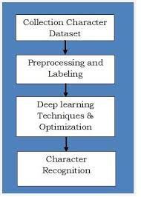

Block diagram proposed handwritten digit recognition system

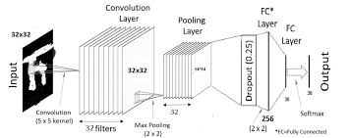

The overall structural design of the CNN Model of our proposed system with different layer.

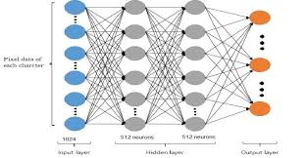

The overall structural design of the DFFNN Model of our proposed system with different layer.

### **Code Requirements**

1. you can install Conda for python which resolves all the dependencies for machine learning.

2. install tensorflow , in conda -> $ conda install tensorflow

3. install keras , in conda -> $ conda install keras

4. install opencv , in conda -> $ conda install opencv

5. handWritingRecognition.py require data set data.csv for training and test

6. application.py require devanagari_model.h5 model for classify the characters.

### **Technique Used**

I have used convolutional neural networks. I am using Tensorflow as the framework and Keras API for providing a high level of abstraction.

### **Architecture**

CONV2D --> MAXPOOL --> CONV2D --> MAXPOOL -->FC -->Softmax--> Classification

**- Intel Optimised Python.  
- Intel Optimised TensorFlow.  
- Keras  
- OpenCV**

# 